EWHA Frontier 10-10 E-CHEMS Seminar Series on Carbon Neutrality

Title: BioEnergy with Carbon Capture and Storage (BECCS) Integrated with Extraction of Energy-Relevant Critical Minerals

Speaker: Ah-Hyung Alissa Park

Lenfest Earth Institute Professor of Climate Change
Department of Earth and Environmental Engineering & Department of Chemical Engineering
Director of the Lenfest Center for Sustainable Energy,
Columbia University, New York, NY 10027

When: 2023. 1. 26. Thur. 10:30~12:00
Where: 연구협력관 103호

Abstract: The Alkaline Thermal Treatment (ATT) reaction presented in this study utilizes wet and salty biomass (e.g., food and agricultural wastes, and seaweeds), which are often ignored resources. This particular biomass conversion reaction is unique, since it integrates in-situ CO₂ capture and co-generate biochar, and solid carbonates such as CaCO₃. Our study has shown that high purity hydrogen can be produced in a single step ATT reaction under mild reaction conditions (ambient pressure and reaction temperature less than 500 C) in the presence of gas reforming Ni-based catalysts. The placement of catalysts and the type of hydroxides are investigated in order to probe the mechanisms of the ATT reaction. Some of these marine biomasses can be cultivated with deep sea water which contains significantly higher metal concentrations. The ATT of these seaweeds can further concentrate metals into solid phase, while producing bio-hydrogen. The extraction and separation of the energy-relevant critical minerals/metals such as rare earth elements, Ni, Co, Li, Ce, and Cu, would provide a sustainable pathway to resource recovery required for our clean energy transition.

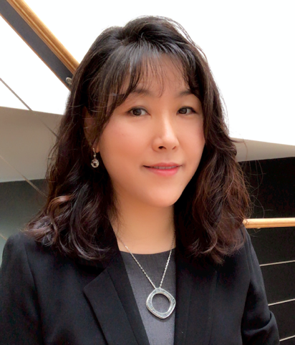
Bio: Ah-Hyung (Alissa) Park is the Lenfest Earth Institute Professor of Climate Change in the Departments of Earth and Environmental Engineering & Chemical Engineering at Columbia University. She is also the Director of the Lenfest Center for Sustainable Energy. Her research focuses on sustainable energy and materials conversion pathways with emphasis on integrated Carbon Capture, Utilization and Storage (CCUS) technologies. Park received a number of professional awards and honors including the Shell Thomas Baron Award in Fluid-Particle Systems at AIChE PTF (2022), ACS ENFL Mid-Career Researcher Award (2022), U.S. C3E Research Award (2018), PSRI Lectureship Award at AIChE PTF (2018), and NSF CAREER Award. Park also led a number of global and national discussions on CCUS including the Mission Innovation Workshop in 2017. Park is a Fellow of AIChE, ACS, RSC and AAAS.

