Title: Understanding and controlling zeolite synthesis

Toru Wakihara (Professor, Ph.D.)
Institute of Engineering Innovation, The University of Tokyo
Yayoi 2-11-16, Bunkyo-ku, Tokyo 113-8656, JAPAN
E-mail: wakihara@chemsys.t.u-tokyo.ac.jp

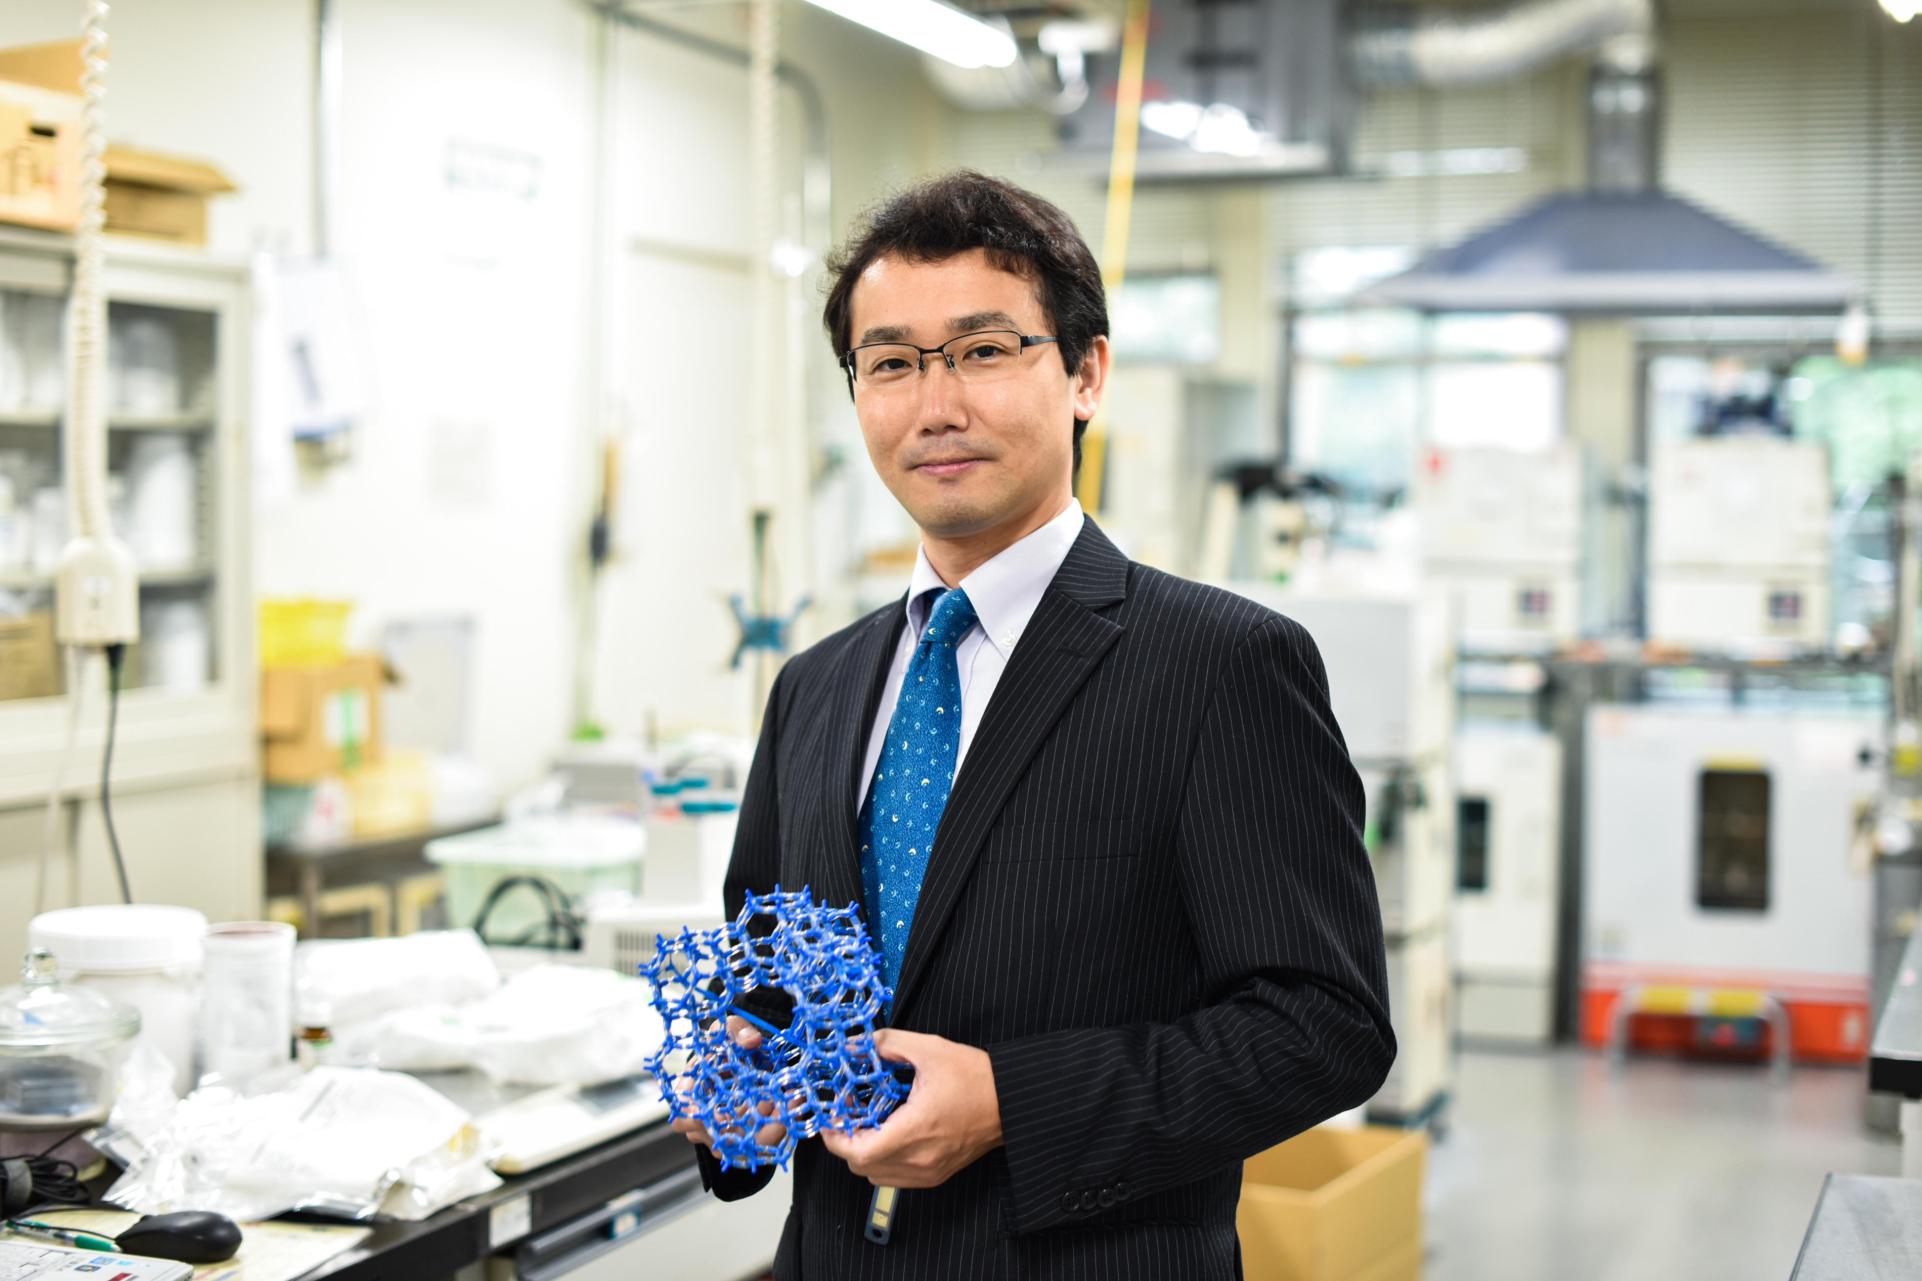Zeolites are artificially synthesized from silicon sources, aluminum sources, mineralizing agents and structure-directing agents in batch systems under hydrothermal conditions. To fulfill the wide industrial demands, efficient synthesis of zeolites with controllable crystallization kinetics is considered crucially important. It is believed that the amorphous aluminosilicate obtained by mixing raw materials first undergoes an induction stage, where its structure changes to a more stable amorphous state, and then a "crystal nucleus," the smallest entity that can be recognized as a crystalline phase, is formed. Thus, if the process of initial structural evolution of zeolites can be clarified and controlled, it will be possible to design and synthesize zeolites with controlled structure and composition in a rational manner. Furthermore, it is expected to make a significant contribution to the discovery of theoretical zeolites with unknown structure and composition. However, the multifaceted formation process of zeolites cannot be simply explained by the classical nucleation theory, in which monomers aggregate to reach a critical size. Furthermore, the aperiodic structure of the aluminosilicate precursor invalidates the conventional crystallographic characterization, and this amorphous-to-crystalline transition process is still a black box. This lecture will focus on the synthesis of zeolites, explaining how zeolites are formed in the hydrothermal synthesis process and how they can be controlled.

