Electrochemistry in the Energy Field
Ara Jo
Department of Chemistry, Kangwon National Univ.
Chunchen-si, Gangwon-do, 24341, Korea

Abstract
Electrochemistry plays a pivotal role in the energy field, offering significant contributions to the development of sustainable and efficient energy conversion and storage technologies. We deal with the electrochemical treatment of CO₂ gas which is a primary greenhouse gas generated through industrial processes, and also overview the fuel cells and electrolyzer systems.
For electrochemical conversion of CO₂ into value-added, we constructed bimetallic electrocatalysts of Zn and Ag on a polypyrrole-decorated carbon paper (CP/PPy) electrode for improved electrochemical reduction of CO₂ into CO and suppressed water reduction into hydrogen gas. The PPy interlayer between the catalysts and carbon paper is utilized to reduce the hydrophobicity of the electrode, so to make effective electrodeposition of Ag and Zn to the CP electrode and to suppress HER at the electrodes. The reaction selectivity of electrochemical CO₂ reduction to CO at CP/PPy/Zn/Ag is obviously improved compared to those of single metal catalyst with suppressing the hydrogen evolution reaction (HER).
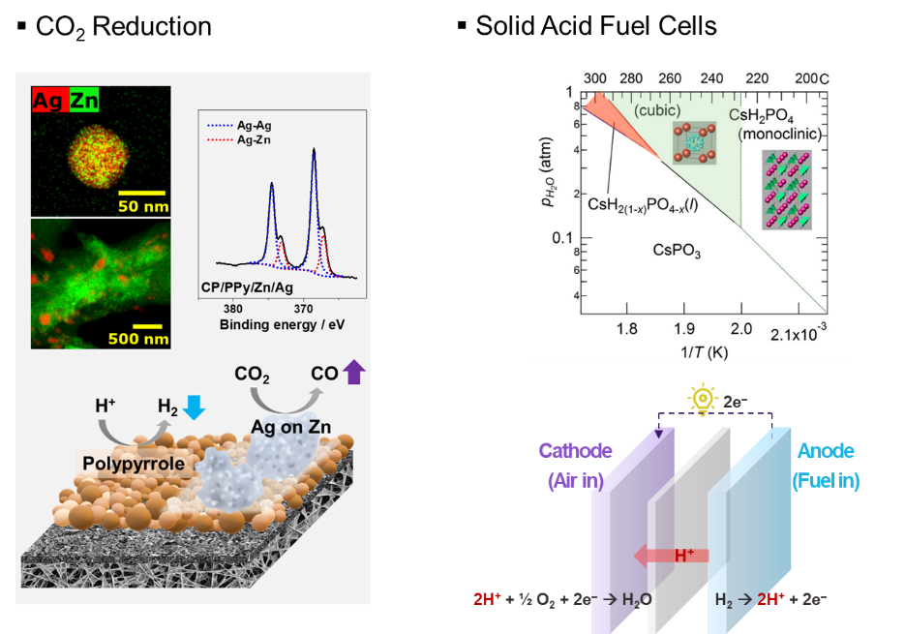
Secondly, we synthesized Cs₂(HSeO₄)(H₂PO₄) (CSP) as a proton-conducting electrolyte for a solid acid fuel cell that operates at 200 - 400 ºC. The CSP shows the presence of a structural phase transition at 120 ºC which is confirmed by differential scanning calorimetric, thermogravimetry, and X-ray diffraction. With the phase transition, the proton conductivity of CSP sharply increased, and its superprotonic behavior maintained until the CSP decomposed at 260 ºC. The CSP is a new discovery for superprotonic solid acid material and it has wide superprotonic window with a low humidity (0.2 atm).

